
Educational Technology

User Tutorial
April 26, 2002

Project Sponsor
Professor Daniel A. Connors
Department of Electrical and Computer Engineering
University of Colorado at Boulder
Campus Box 425, Boulder, CO 80309-0425

Project Team
Joel Dice - Gabe Johnson - Jamie Lunsford - Eric Minick - Andrew Strotheide
Department of Computer Science, University of Colorado at Boulder
Table of Contents

1 Introduction 1
2 Using OneBook 2
2.1 Students and Instructors 2
2.1.1 Logging In to OneBook 2
2.1.2 The Portal Page and Navigation Bar 3
2.1.3 Assignment Detail and Submission 5
2.1.4 Logging out 6
2.2 For Instructors Only 6
2.2.1 Creating an Assignment 6
2.2.2 Collecting an Assignment 10
2.2.3 Grading an Assignment 12
2.2.4 Logging out 13
3 Additional resources 13
4 Document Revision History 13

Introduction

OneBook Educational Technology is a unified mechanism by which students and teachers can effectively exchange course materials for many classes, giving students the ability to archive that course data, and instructors the ability to compile statistics that represent their students’ abilities and performance in their classes.

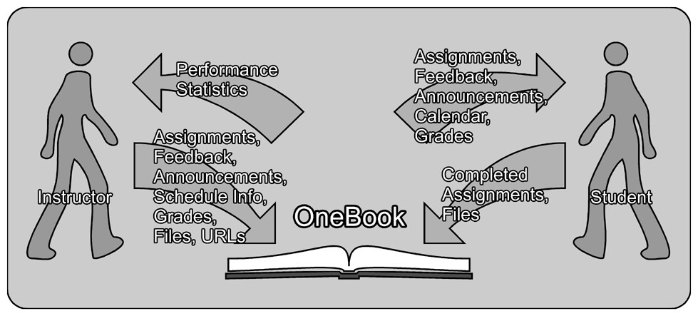
Our conceptual diagram, Figure 1, shows the interaction between students and instructors. In order for OneBook to properly function, everyone involved must put something in, so that everyone can reap the benefits. OneBook is not intended to be a way to minimize the interaction between students and instructors, but rather to be an aid for maximizing the benefits of that interaction.

Figure 1: Top Level Overview

This document is the User Tutorial and the intended use is by new users of OneBook. The first part is for instructors and students, with more information about how instructors use OneBook following. This manual assumes a basic knowledge of the Internet and how basic forms work. Only the major ideas of OneBook are given here; for more detailed information, and a more formal discussion, see the OneBook User Reference Manual.

Using OneBook
This tutorial will help you to find your way through the OneBook system. It is divided into two parts, Students and Instructors, and For Instructors Only. The first part will help both students and instructors, and the second will talk about things only the instructor can accomplish.

Students and Instructors
This part of the tutorial covers logging in, the portal page and navigation bar, how to get help, how to check an assignment, how to submit an assignment and how to log out.

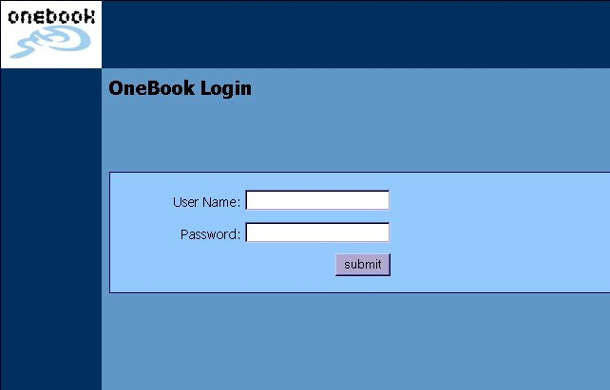
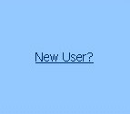
Logging In to OneBook
Figure 2: Login Screen

The first page you will see when you go to the OneBook site will be the login page, Figure 2. This is the screen where you input your User Name and Password, as given to you by your instructor or System Administrator. If you don’t have a User Name and want one, you can click on the “New User” link and send an e-mail to the System Administrator.

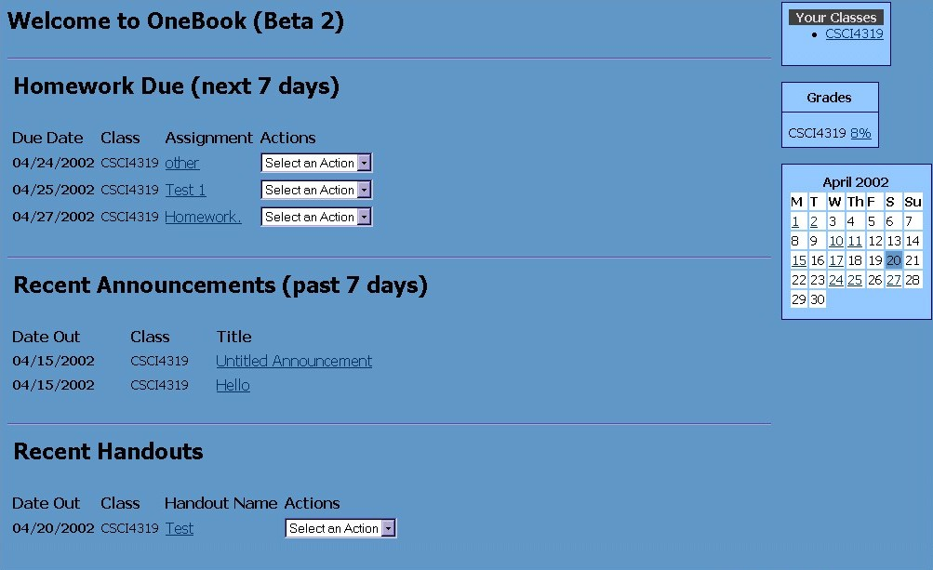
The Portal Page and Navigation Bar

Figure 3: Portal Page

The Portal is the first page you will see after you login. There are two main parts to this page, the Portal in Figure 3, and the Navigation Bar, Figure 4.

The Portal contains time-sensitive information about all of your classes. It will tell you any homework that is due, announcements that have been made, or handouts that have been released. You can see more detailed information about each item by clicking on its link.

On the right hand side are a list of classes you are in, a grades box, and a calendar. Clicking on one of your classes will take you to the Portal page for that class. The grades box shows your current grade in any class in which you are a student, or the class average if you are the instructor. The calendar shows the current month, and any dates that are underlined indicate that something is happening on that day: a test, a homework due, etc.

Figure 4: Navigation Bar

The Navigation Bar, Figure 4, shows the major places you might want to go.

My Classes will take you to a list of classes, where you can view assignments, announcements, etc.; if you are an instructor, you can change the class information.

Groups lets you see what groups you are a part of, or create a new group.

The Browser is where you can upload files or look for an assignment.

Grades will let you view your grades on certain assignments, or grade assignments if you’re the instructor.

Assignments, Handouts, and Announcements are similar. If you’re a student, you can view them in detail; if you’re an instructor, you can also create new ones.

The Course box lets you choose which class you’re seeing.

Show Help allows you to view online help, illustrated in Figure 5. The link will then become Hide Help, which allows you to close the online help.

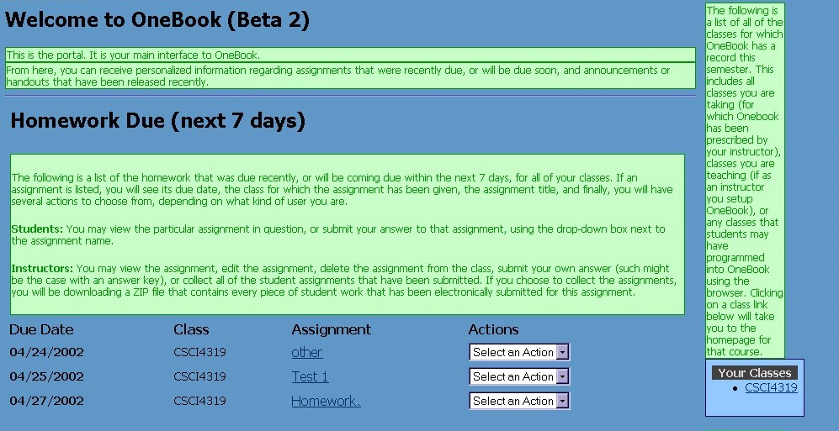
Log Out logs you out of the system.
Figure 5: Show Help

Assignment Detail and Submission
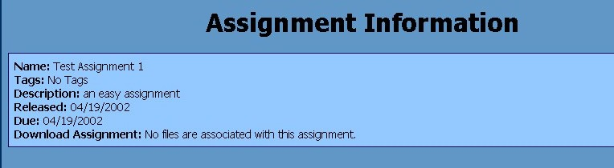
Now that you know what the portal is, let’s view an assignment in detail. If you click on one of your assignments from the Portal page, you’ll get to a page that looks like Figure 6 at the top.
Figure 6: Assignment Detail

This is all of the information about the assignment. If there were a file to download, you’d click on the link that would be displayed. It shows the day the instructor released it, and the day it’s due. If you’re a student, there’s a submit button on the left hand side of the page that will bring up a submit screen, Figure 7.
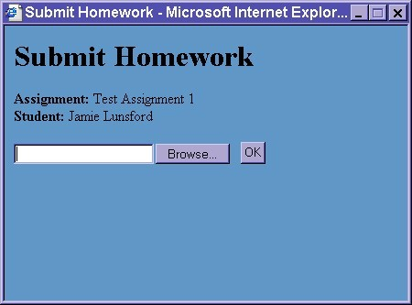
Figure 7: Submit Homework

Clicking the Browse button lets you find your homework and electronically submit it.

Logging out
Don’t forget to click the Log Out button in the upper right hand corner of the screen, Figure 4, when you’re finished with OneBook. Otherwise, someone could get access to your session. For tighter security, close your browser after you’re finished with OneBook.

That’s all for the student part of the tutorial. There are a lot more things you can do in OneBook, but that should be enough to get you started.

For Instructors Only
This section of the tutorial covers topics that only apply to instructors. It will show you how to create, collect, and grade an assignment.

Creating an Assignment

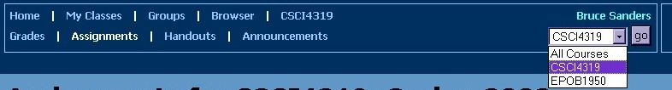
For instructors, OneBook can also help you control the necessary paperwork for a class. Since you’re on the Assignments page anyway, let’s create a new assignment. You can create a new assignment from this page, but I want to show you something else about the Navigation Bar. Click on the Assignments link in the Navigation Bar. In order to create an assignment, you’ll need to be in the class context. To do that, click on the pull-down menu in the Navigation bar, shown in Figure 8. Choose the course you want to create an assignment for, and then click the go button.
Figure 8: Pull-Down Class Menu

Now a left hand side bar, Figure 9, will appear. Clicking on Create Assignment will create a new assignment for this course, and Figure 10 will be the next screen you see.
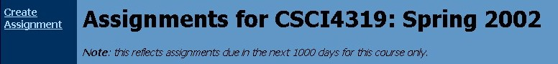
Figure 9: Create Assignment Link

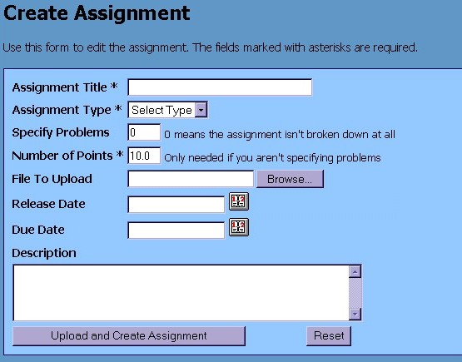
Figure 10: Create Assignment

There are lots of fields you can fill in for the assignment, but the only required fields are the Assignment Title, Assignment Type, and Problems or Number of Points. Either Problems or Number of Points needs to be chosen. If you specify how many problems the assignment is worth, the total number of points will come from how many points each problem is worth.

The Assignment Type is used to determine where an assignment fits into the Grading Plan and allows for a more accurate calculation of student grades.

If you want a file associated with this assignment, click Browse and find the file you want attached.

Clicking the calendar by Release Date and Due Date will give the Date Picker, shown in Figure 11. Click the date you want and it will automatically fill it in for you.

Finally, there’s the Description of the assignment. If you are handing out an assignment online, even if you want your assignment to have multiple problems, you’ll need to put any information into the Description box. Once you’re finished filling out the form, click Upload and Create Assignment.
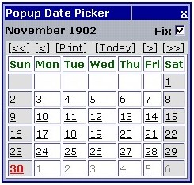
Figure 11: Date Picker

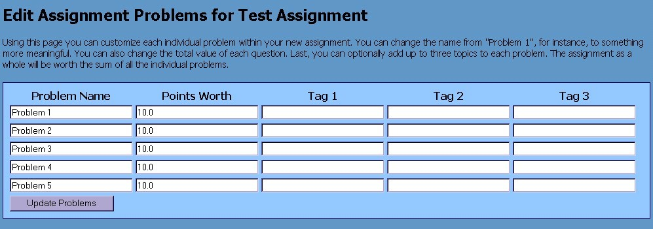
If you specified a number of problems, then the Edit Problems page, Figure 12, will be the next page you see.
Figure 12: Edit Problems

This page will allow you to determine how many points each problem is worth, and associate one or more Tags to each problem. A Tag is a descriptor you can add to an problem or assignment so that students can later find the assignment based on the Tag. An example tag would be a tag called “Osmosis” for a biology assignment.
After you’ve created the assignment, you’ll be brought back to the Assignment Detail page that we started from. This page also has Tags that can be added to the assignment. Figure 13 shows the Tags as they pertain to an assignment.

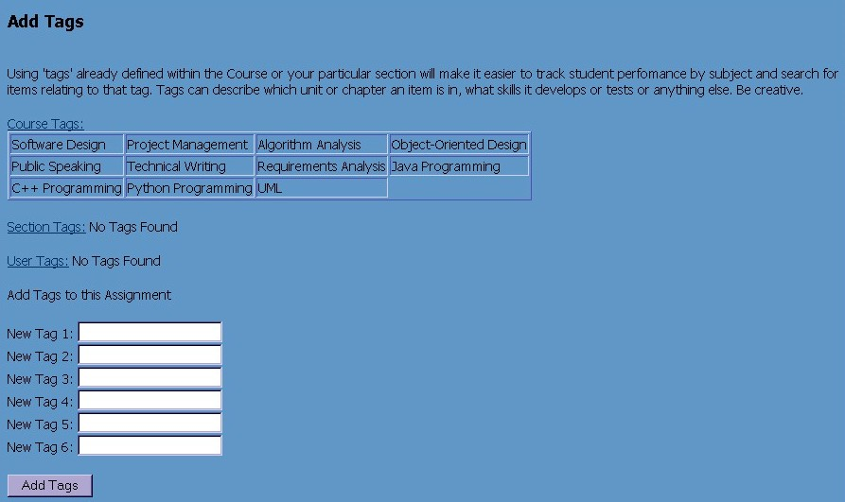
Figure 13: Add Tags to an Assignment

There are three different Tag Dictionaries. Each one is accessible by an increasingly smaller group. For example, the Course Tag Dictionary might have tags the course would always use, such as “Partial Differential Equation”, “Integral”, and “Differential” for a calculus course. The Section Tag Dictionary would contain only those tags used for a specific course section, such as “War and Peace”, “The Scarlet Pimpernel”, and “The Bell Jar” for an English course. The User Tag Dictionary contains tags that are only accessible to you.

Clicking on a Tag Dictionary link will take you to where you can change that dictionary, if you have proper authorization. The available tags are shown underneath each link. To add new tags to an assignment, type one or more valid tags into the text boxes and click Add Tags.
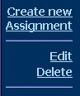
If you accidentally put in some of the wrong information for the assignment, such as the wrong date, or if you add information to the assignment after it’s been released, you can click on the Edit link in the left hand bar, Figure 14. If you decide you don’t need the assignment, you can click the Delete button in the left hand bar. You can also choose to Create a New Assignment to make another assignment for this class.
Figure 14: Assignment Detail

Collecting an Assignment
Earlier we showed how easy it is to submit an assignment. Now we’ll show how easy it is for you to collect the submitted assignments. Click on My Classes in the Navigation Bar, and the My Classes page, Figure 15, will come up. This page has all the classes you are currently teaching, and allows you to click between different pages without having to change the class context in the Navigation Bar.
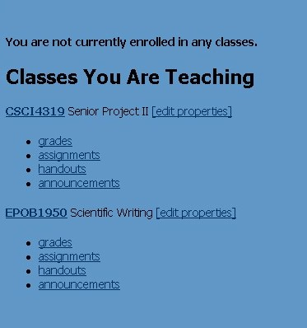
Figure 15: My Classes
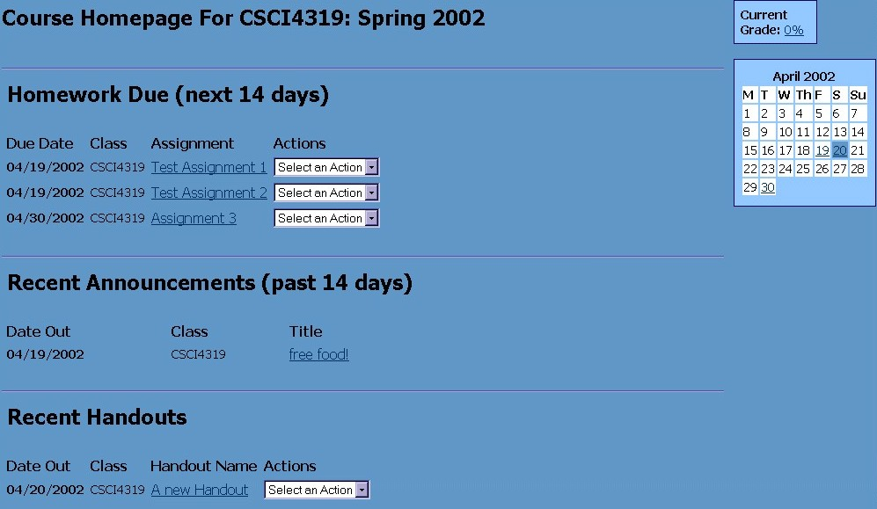
Click on the class that has the assignment you want to collect. You’ll be taken to the Class Portal page, Figure 16. This page is much like the first page we encountered, but has the information for only the specific class that was selected.
Figure 16: Class Portal

The assignment to collect should be shown under the Homework Due title. If not, then the assignment’s due date has passed and we’ll have to get there a slightly different way. In order to collect the assignment, click on the pull-down menu and choose Collect. This will collect and download all submitted assignments into a zip file. That it!

Unless, of course, the assignment due date has passed. In that case, click on Grades in the Navigation bar. This will take you to the Grades page, Figure 17, for this class.
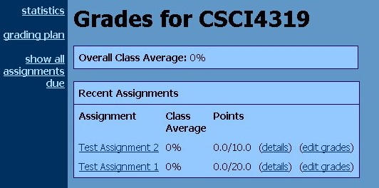
Figure 17: Grades

If you click show all assignments due, it will show any assignment that has been created for this class. Clicking on the title of the assignment will take you to the Assignment Detail page, and clicking Collect will allow you to collect the homework.

Grading an Assignment
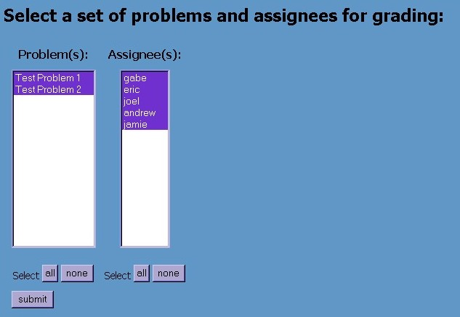
Now that we’ve collected the assignment, you can grade it (unfortunately, OneBook doesn’t offer a grading service!), and then we’ll put the grades into OneBook. Starting from the Grades page, Figure 17, click on edit grades next to the assignment you want to grade. If you don’t see assignment names, remember to select which class the assignment is in from the drop down box in the Navigation Bar, Figure 8. Clicking on edit grades will take you to a page where you can choose which grades you want to input, Figure 18.
Figure 18: Select Problems and Assignees

You can choose problems and Assignee(s) with the all and none buttons, or by choosing specific people or problems with the mouse. Holding down the Ctrl key and using the mouse will allow you to select more than one person or problem. By default, every person and every problem will be selected. Click the submit button when you’re finished.
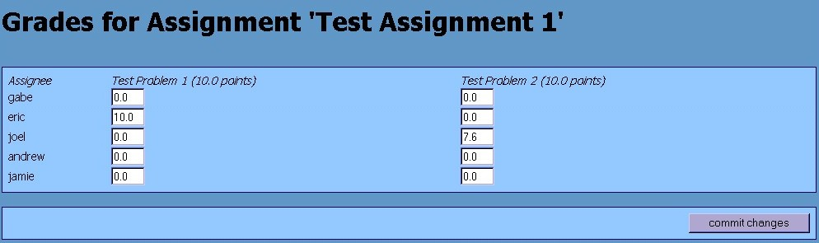
Now you see the grading matrix, Figure 19. After you’re done inputting the student grades, click the commit changes button. A message will appear at the top of the screen informing you that your changes have been recorded.

Figure 19: Grading matrix

Logging out
Don’t forget to click the Log Out button in the upper right hand corner of the screen, Figure 4, when you’re finished with OneBook. Otherwise, someone could get access to your session. For tighter security, close your browser after you’re finished with OneBook.

Additional resources
This document has provided information about using some of the more basic features of OneBook. Further information can be found in the OneBook User Reference Manual, or by reading the online help.

Document Revision History
4/23/2002 | 0.1 | Original document creation | Jamie Lunsford
4/26/2002 | 0.2 | Added Figure Captions and changed things per Jim’s comments | Jamie Lunsford
5/6/2002 | 1.0 | Added Introductions to Headings per Bruce’s comments | Jamie Lunsford

